**OPEN CV**

OpenCV is a popular open-source computer vision and machine learning software library. It provides a wide range of tools and functions for various computer vision tasks, such as object detection, recognition, tracking, and image processing. OpenCV is written in C++, but it also provides interfaces for other programming languages such as Python and Java. It has a large community and is widely used in both academic research and industry applications. With OpenCV, developers can build powerful computer vision applications that can analyze and understand images and videos in real-time.

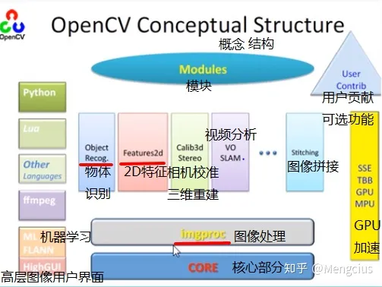

**YOLO**

YOLO (You Only Look Once) is a real-time object detection system developed by Joseph Redmon, Ali Farhadi, and their team at the University of Washington. It uses a single neural network to predict bounding boxes and class probabilities directly from full images in one evaluation.

YOLO is known for its speed and accuracy, as it can detect and classify objects in real-time video streams with low latency. The YOLO architecture divides an input image into a grid of cells, and for each cell, the model predicts a set of bounding boxes ,which indicate the likelihood of an object being present in that box. The model also predicts the class probabilities for each bounding box.

